**E-Commerce Web App**

**A PROJECT REPORT**

**For**

**Mini Project (KCA353)**

**Session (2023-24)**

**Submitted by**

**Harsh kain**

**2200290140065**

**Submitted in partial fulfilment of the**

**Requirements for the Degree of**

**MASTER OF COMPUTER APPLICATION**

**Under the Supervision of**

**Ms. Shalika Arora**

**Assistant Professor**



**Submitted to**

**Department Of Computer Applications**

**KIET Group of Institutions, Ghaziabad**

**Uttar Pradesh-201206**

**(December 2023)**

**CERTIFICATE**

Certified that **Harsh Kain Roll No. 2200290140065** has / have carried out the project work having “**E-Commerce Web APP**” (**Mini Project-KCA353**) for **Master of Computer Application** from Dr. A.P.J. Abdul Kalam Technical University (AKTU**)** (formerly UPTU), Lucknow under my supervision. The project report embodies original work, and studies are carried out by the student himself/herself and the contents of the project report do not form the basis for the award of any other degree to the candidate or to anybody else from this or any other University/Institution.

**Harsh Kain (University Roll No-2200290140065)**

This is to certify that the above statement made by the candidate is correct to the best of my knowledge.

**Date:**

**Ms. Shalika Arora Dr. Arun Tripathi**

**Assistant professor Head**

**Department of Computer Applications Department of Computer Applications**

**KIET Group of Institutions, Ghaziabad KIET Group of Institutions, Ghaziabad**

**Harsh kain**

**ABSTRACT**

E-commerce is the activity of buying or selling products on online services or over the Internet. Electronic commerce draws on technologies such as mobile commerce, electronic funds transfer, supply chain management, Internet marketing, online transaction processing, electronic data interchange (EDI), inventory management systems, and automated data collection systems.

Most small stores in India do not have an online presence; requiring customers to visit the store in person to buy any product. This requirement to visit the store hurts it by driving down the profits. With near free hosting services, it takes minimal resources to set up an e- commerce website which allows customers to purchase at the convenience of their home.

E-commerce means any transaction over the internet. In online marketing, a shopping cart piece of e-commerce software on a web server that allows visitors to an Internet site to select items for eventual purchase, analogous to the American English term “shopping cart.”

The software allows online shopping customers to accumulate a list of items for purchase, described metaphorically as “placing items in the shopping cart” or “add to cart.” Upon checkout, the software typically calculates a total for the order, including shipping and handling (i.e., postage and packing) charges and the associated taxes, as applicable.

**ACKNOWLEDGEMENT**

Success in life is never attained single handedly. My deepest gratitude goes to my thesis supervisor, Ms. Shalika Arora (Assistant Professor) for their guidance, help and encouragement throughout my project work. Their enlightening ideas, comments, and suggestions have guided me a lot in completing this project successfully.

Words are not enough to express my gratitude to Dr. Arun Kumar Tripathi, Professor and Head, Department of Computer Applications, for his insightful comments and administrative help at various occasions. Fortunately, I have many understanding friends, who have helped me a lot on many critical conditions.

Finally, my sincere thanks go to my family members and all those who have directly and indirectly provided me moral support and other kind of help. Without their support, completion of this work would not have been possible in time. They keep my life filled with enjoyment and happiness.

Harsh Kain (2200290140065)

**TABLE OF CONTENT**

|  |  |  |  |
| --- | --- | --- | --- |
|  | Certificate | | ii |
|  | Abstract | | iii |
|  | Acknowledgements | | iv |
|  | Table of Contents | | v |
|  | List of Tables | | vii |
|  | List of Figures | | viii |
| **1** | **Introduction** | | **1-5** |
|  | 1.1 | Overview | 1 |
|  | 1.2 | Problem Statement | 1 |
|  | 1.3 | Objective | 2 |
|  | 1.4 | Scope | 2 |
|  | 1.5 | Features | 3 |
|  | 1.6 | Hardware/ Software used in project | 4 |
|  | 1.7 | Background | 4 |
| **2** | **Feasibility Study** | | **6-14** |
|  | 2.1 | Economical Feasibility | 6 |
|  | 2.2 | Technical Feasibility | 8 |
|  | 2.3 | Operational Feasibility | 10 |
|  | 2.4 | Behavioural feasibility | 12 |
| **3** | **Software requirement specification** | | **15-19** |
|  | 3.1 | Functionalities | 15 |
|  | 3.2 | User and Characteristics | 16 |
|  | 3.3 | Features of project | 17 |
|  | 3.4 | Feature of Admin | 17 |
|  | 3.4 | Features of User | 18 |
| **4** | **System Requirement** | | **20-30** |
|  | 4.1 | Functional Requirement | 20 |
|  | 4.2 | Non-Functional Requirement | 21 |
|  | 4.3 | Design Goal | 23 |
| **5** | **System Design** | | **31-33** |
|  | 5.1 | Primary Design Phase | 31 |
|  | 5.2 | Secondary Design Phase | 32 |
|  | 5.3 | User Interface | 33 |
| **6** | **Architecture** | | **34-36** |
|  | 6.1 | Layered Architecture | 34 |
| **7** | **Project Screenshots** | | **37-45** |
| **8** | **Conclusion** | | **46** |
| **9** | **Bibliography** | | **47** |
|  |  |  |  |
|  |  |  |  |
|  |  |  |  |
|  |  | |  |
|  |  | |  |

|  |  |  |
| --- | --- | --- |
| **Table No.** | **Name of Table** | **Page** |
| 1.1 | Hardware Requirement | 4 |
| 1.2 | Software Requirement | 4 |
|  |  |  |
|  |  |  |
|  |  |  |
|  |  |  |

**LIST OF TABLE**

|  |  |  |  |
| --- | --- | --- | --- |
| **Figure No.** | **Name of Figure** | **Page No.** | |
| 4.1 | Use case diagram | | 24 | |
| 4.2 | ER- diagram | | 25 | |
| 4.3 | Data flow diagram | | 26 | |
| 4.4 | Class Diagram | | 27 | |
| 4.5 | Level 0 DFD Diagram | | 28 | |
| 4.6 | Level 1 DFD Diagram | | 29 | |
| 4.7 | Level 2 DFD Diagram | | 30 | |
| 6.1 | Architecture of E-commerce web app | | 36 | |
| 7.1 | Login/ Sign up Page | | 37 | |
| 7.2 | All Products Page | | 38 | |
| 7.3 | Product Details | | 39 | |
| 7.4 | Address Page | | 40 | |
| 7.5 | Payment Page | | 41 | |
| 7.6 | Checkout Page | | 42 | |
| 7.7 | User Profile Page | | 43 | |
| 7.8 | Admin Products update | | 44 | |
| 7.9 | Admin Products Add/ Delete | | 45 | |

**LIST OF FIGURE**

**Chapter 1**

**Introduction**

* 1. **Overview**

The "Online E-commerce System" has been developed to override the problems prevailing in the practicing manual system. This software is supported to eliminate and in some cases reduce the hardships faced by this existing system. Moreover this system is designed for the particular need of the company to carry out operations in a smooth and effective manner. The application is reduced as much as possible to avoid errors while entering the data. It also provides error message while entering invalid data. No formal knowledge is needed for the user to use this system. Thus by this all it proves it is user-friendly. Online E-commerce System, as described above, can lead to error free, secure, reliable and fast management system. It can assist the user to concentrate on their other activities rather to concentrate on the record keeping. Thus it will help organization in better utilization of resources. Every organization, whether big or small, has challenges to overcome and managing the information of Item Category, Men, Woman, Child, Delivery Address, Order. Every Online E-commerce System has different Food needs, therefore we design exclusive employee management systems that are adapted to your managerial requirements. This is designed to assist in strategic planning, and will help you ensure that your organization is equipped with the right level of information and details for your future goals. Also, for those busy executive who are always on the go, our systems come with remote access features, which will allow you to manage your workforce anytime, at all times. These systems will ultimately allow you to better manage resources.

* 1. **Problem Statement**

In the rapidly evolving landscape of online commerce, there is a growing demand for robust and scalable e-commerce platforms. Traditional methods of shopping are being replaced by digital experiences, creating a need for feature-rich and user-friendly online stores. Existing e-commerce solutions often come with limitations, making it challenging for businesses to tailor their platforms to specific needs and requirements.

* 1. **Objectives**

The main objective of the Project on Online E-commerce System is to manage the details of Clothes, Item Category, Shopping Cart, Customer, Order. It manages all the information about Clothes, Delivery Address, and Order. The project is totally built at administrative end and thus only the administrator is guaranteed the access. The purpose of the project is to build an application program to reduce the manual work for managing the Clothes, Item Category, Delivery Address, and Shopping Cart. It tracks all the details about the Shopping Cart, Customer, and Order.

* 1. **Scope**

It may help collecting perfect management in details. In a very short time, the collection will be obvious, simple and sensible. It will help a person to know the management of passed year perfectly and vividly. It also helps in current all works relative to Online E-commerce System. It will be also reduced the cost of collecting the management & collection procedure will go on smoothly. Our project aims at Business process automation, i.e. we have tried to computerize various processes of Online E-commerce System.

* In computer system the person has to fill the various forms & number of copies of the forms can be easily generated at a time.
* In computer system, it is not necessary to create the manifest but we can directly print it, which saves our time.
* To assist the staff in capturing the effort spent on their respective working areas.
* To utilize resources in an efficient manner by increasing their productivity through automation.
* The system generates types of information that can be used for various purposes.
* It satisfy the user requirement
* Be easy to understand by the user and operator
* Be easy to operate
* Have a good user interface
* Be expandable
* Delivered on schedule within the budget
  1. **Feature**
* Product and Component based

Creating & Changing Issues at ease

* Query Issue List to any depth
* Reporting & Charting in more comprehensive way
* User Accounts to control the access and maintain security
* Simple Status & Resolutions
* Multi-level Priorities & Severities.
* Targets & Milestones for guiding the programmers
* Attachments & Additional Comments for more information
* Robust database back-end
* Various level of reports available with a lot of filter criteria's
* It contain better storage capacity.
* Accuracy in work.
* Easy & fast retrieval of information.
* Well-designed reports.
* Decrease the load of the person involve in existing manual system.
* Access of any information individually.
* Work becomes very speedy.
* Easy to update information
  1. **Hardware / Software Requirement**

Hardware Requirement

Table 1.1 Hardware Requirement

|  |  |
| --- | --- |
| **S. N.** | **Description** |
| 1 | PC with 5 GB or more Hard disk. |
| 2 | PC with 2 GB RAM. |
| 3 | PC with core i3 or above processor. |

Software Requirements

Table 1.2 Software Requirement

|  |  |  |
| --- | --- | --- |
| **S. N.** | **Description** | **Type** |
| 1 | Operating System | Windows 8 or Above |
| 2 | Front End | React 17 |
| 3 | IDE | Google Colab, VS Code |
| 4 | Browser | Chrome, Firefox, Edge |

* 1. **Background**

Online Shopping nowadays is becoming a trend where customers are embracing it due to its many benefits. From the point of view of consumers, this trend offers low and clear, and transparent pricing. A point to mention, a wide range of products and services which is more convenient to shoppers than the traditional way of Shopping by visiting the store such as waiting in line at the cash window, parking space issues especially at the mall, crowded stores in sale season…So there, understanding, analyzing and learning consumer behavior is crucial for any business success whether it is operating online or offline.

Whatever the market is, the main focus is to provide and ensure customers’ needs. Online Shopping is becoming more frequent, using the internet to promote and market a product or service or even a store, so people might become familiar with it and visit the store.

The balanced competition between these two mediums of Shopping (online and offline) has marked the beginning of a new generation where customers can choose the desired channel that suits them more to purchase their needs. The aim of online Shopping or offline Shopping is to attract consumers and delivering them the most satisfying experience to ensure that the customer will come back. Retailers are facing

More diversified and more sophisticated consumer demands and need due to Globalization nowadays.

They are the key drivers of any business. To cope with such changes, reach an ideal profit maximization since every market aims to develop itself and offer its customers the finest goods and services. Since the digital world is spreading and people are becoming more familiar with it as it’s becoming a daily use, retailers who operate online.

**CHAPTER 2**

**FEASIBILITY STUDY**

After doing the project Online E-commerce System, study and analyzing all the existing or required functionalities of the system, the next task is to do the feasibility study for the project. All projects are feasible - given unlimited resources and infinite time. Feasibility study includes consideration of all the possible ways to provide a solution to the given problem. The proposed solution should satisfy all the user requirements and should be flexible enough so that future changes can be easily done based on the future upcoming requirements.

* 1. **Economical Feasibility**

Economic feasibility is a critical aspect of evaluating the viability of an e-commerce project, examining the financial investment required against the anticipated returns. The project's economic feasibility is determined by factors such as development costs, operational expenses, and potential revenue streams. Initial investments in website development, security infrastructure, and marketing campaigns are weighed against the projected sales and profitability. Additionally, considerations like maintenance costs, hosting fees, and payment gateway expenses contribute to the economic analysis. The e-commerce project's viability is further supported by the potential for scalability, cost-effectiveness of technology solutions, and the ability to capitalize on market trends. A positive economic feasibility assessment ensures that the e-commerce venture has the potential to generate sustainable revenue and achieve a satisfactory return on investment, making it a financially sound endeavor.

Economic feasibility in the context of an e-commerce project encompasses various financial considerations that are crucial for determining its viability and potential success. Here's a more detailed explanation of the aspects involved:

**Development Costs**: This includes expenses associated with creating the e-commerce platform, such as hiring developers, purchasing necessary software, designing the user interface, and integrating essential features like shopping carts, payment gateways, and inventory management systems.

**Operational Expenses:** These are ongoing costs required to keep the e-commerce business running smoothly. They may include expenses related to website maintenance, customer support, server hosting, inventory management, fulfillment services, and any other operational overheads.

**Revenue Streams:** This refers to the different sources of income that the e-commerce project can potentially generate. Common revenue streams for e-commerce businesses include product sales, subscription services, advertising revenue, affiliate marketing, and data monetization.

**Projected Sales and Profitability:** Based on market research, competitor analysis, and business projections, the expected sales volume and profitability of the e-commerce venture are estimated. This involves forecasting demand, setting pricing strategies, and identifying target customer segments to gauge potential revenue generation.

**Maintenance Costs:** Beyond initial development, there are ongoing expenses associated with maintaining and updating the e-commerce platform to ensure optimal performance, security, and user experience. This may include software updates, security patches, bug fixes, and other routine maintenance tasks.

**Hosting Fees:** The cost of hosting the e-commerce website on servers is another significant expense. Factors such as server capacity, bandwidth usage, data storage, and uptime reliability contribute to determining the hosting fees.

**Payment Gateway Expenses:** Processing payments securely and efficiently is essential for any e-commerce business. Payment gateway providers typically charge transaction fees or a percentage of each sale, which adds to the operational costs of the e-commerce project.

**Scalability:** The ability of the e-commerce platform to accommodate growth and handle increased traffic, transactions, and data volume without significant disruptions or performance issues is crucial for long-term success. Scalability often influences both development and operational costs.

**Cost-Effectiveness of Technology Solutions:** Evaluating the efficiency and cost-effectiveness of technology solutions, such as e-commerce platforms, content management systems, analytics tools, and marketing automation software, helps optimize resource allocation and maximize ROI.

* 1. **Technical Feasibility**

Technical feasibility is a critical component in assessing the viability of an e-commerce project, focusing on the technological infrastructure required for its successful implementation. The project's technical feasibility involves evaluating the compatibility and capability of existing or proposed technology to meet the project's objectives. This encompasses considerations such as website development, hosting, database management, and integration with other systems. The platform must ensure security for online transactions, data protection, and user privacy. Scalability and adaptability to future technological advancements are crucial,

Ensuring the e-commerce project can evolve with emerging trends. Technical feasibility also

Involves assessing the availability of skilled resources, expertise, and the feasibility of implementing required features such as mobile responsiveness and application programming interfaces (APIs). A positive technical feasibility study confirms that the chosen technology stack aligns with project requirements, ensuring a robust and sustainable e-commerce platform.

Technical feasibility refers to the examination of the technological aspects involved in the successful execution of an e-commerce project. Here's a detailed explanation of the components:

**Compatibility and Capability of Technology:** This involves assessing whether the existing or proposed technological infrastructure is suitable for meeting the objectives of the e-commerce project. It includes evaluating hardware, software, and networking components to ensure they work together seamlessly to support the desired functionality.

**Website Development:** Technical feasibility evaluates the feasibility of developing the e-commerce website or platform, considering factors such as the chosen programming languages, frameworks, content management systems (CMS), and development methodologies. It also includes considerations for responsive design, ensuring the website functions effectively across various devices and screen sizes.

**Database Management:** Managing databases efficiently is crucial for storing and retrieving product information, customer data, transaction records, and other essential information. Technical feasibility examines database technologies, schema design, data normalization, indexing strategies, and backup and recovery procedures to ensure optimal performance, reliability, and data integrity.

**Integration with Other Systems:** E-commerce platforms often need to integrate with third-party systems and services, such as payment gateways, shipping carriers, inventory management systems, and customer relationship management (CRM) software. Technical feasibility assesses the feasibility of integrating these systems seamlessly while maintaining data consistency, security, and reliability.

**Security:** Ensuring the security of online transactions, sensitive customer information, and the overall e-commerce platform is paramount. Technical feasibility evaluates security measures such as encryption, secure sockets layer (SSL) certificates, firewalls, intrusion detection systems (IDS), and compliance with industry standards like PCI-DSS (Payment Card Industry Data Security Standard).

**Scalability and Adaptability:** Technical feasibility considers the scalability of the e-commerce platform to accommodate growth in user traffic, product inventory, and transaction volume. It also assesses the adaptability of the technology stack to incorporate future advancements and emerging trends in e-commerce, such as artificial intelligence (AI), machine learning (ML), voice commerce, and augmented reality (AR).

**Availability of Skilled Resources and Expertise:** Assessing technical feasibility involves evaluating the availability of skilled developers, engineers, designers, and other technical professionals with the expertise required to implement and maintain the e-commerce platform effectively.

**Mobile Responsiveness and APIs:** Technical feasibility examines the feasibility of implementing features such as mobile responsiveness for optimal user experience on Smartphones and tablets. It also assesses the availability and usability of application programming interfaces (APIs) for integrating with external services and enabling customizations and third-party integrations.

* 1. **Operation Feasibility**

Operational feasibility for an e-commerce project involves evaluating whether the proposed system can be effectively integrated into the existing business operations and processes. It assesses the practicality of implementing the e-commerce platform within the organizational framework. Factors such as the impact on day-to-day operations, employee training, and workflow adjustments are considered. The operational feasibility study also explores how well the e-commerce system aligns with the company's strategic goals and whether it enhances overall efficiency. Assessing the ease of use for both customers and employees, as well as the compatibility with existing software and procedures, is crucial. A positive operational feasibility analysis ensures that the e-commerce project can be seamlessly integrated, optimizing business processes and contributing to the overall success of the organization.

Operational feasibility assesses whether a proposed project can be implemented effectively from an operational standpoint. Here's a breakdown of the key aspects involved:

**Operational Processes:** Evaluate the existing operational processes within the organization and determine how the proposed project will fit into or impact these processes. Considerations include workflow changes, resource allocation, and potential disruptions to existing operations.

**Resource Availability:** Assess the availability of human, financial, and technological resources required to implement and sustain the project. This involves evaluating staffing needs, budgetary constraints, and access to necessary equipment or technology.

**Training and Skills:** Determine if the organization's staff have the required skills and expertise to support the project. Consider whether additional training or hiring of specialized personnel will be necessary to ensure successful implementation and ongoing operation.

**Organizational Structure:** Consider how the project will align with the organization's structure and culture. Assess potential impacts on reporting relationships, decision-making processes, and communication channels within the organization.

**Risk Management:** Identify potential risks and challenges associated with the project's implementation and operation. Develop strategies to mitigate these risks and ensure that the project can proceed smoothly without significant disruptions or adverse consequences.

**Regulatory and Legal Compliance:** Ensure that the project complies with relevant laws, regulations, and industry standards. Assess any potential legal or regulatory barriers that may affect the project's feasibility and develop strategies to address them.

**Change Management:** Evaluate the organization's capacity to manage change and adapt to the introduction of new processes or technologies. Develop a change management plan to facilitate smooth transitions and minimize resistance to change among employees.

**Measurable Objectives:** Define clear and measurable objectives for the project to gauge its success and effectiveness once implemented. Establish key performance indicators (KPIs) to track progress and ensure that the project is meeting its intended goals.

**Stakeholder Buy-In:** Obtain buy-in and support from key stakeholders within the organization. Communicate the benefits of the project and address any concerns or objections raised by stakeholders to ensure alignment and commitment to the project's success.

* 1. **Behavioural Feasibility**

Behavioural feasibility assesses the willingness of users, both customers and employees, to accept and adopt the proposed e-commerce project. In the context of an e-commerce platform, understanding user behaviour is critical for success. It involves studying user preferences, online shopping habits, and their comfort with digital transactions. Customer receptiveness to new features, such as personalized recommendations, secure payment methods, and user-friendly interfaces, is evaluated. Employee buy-in and adaptability to new processes, like order fulfilment and customer support through digital channels, are also considered. A positive behavioural feasibility analysis indicates that the target audience is

Likely to embrace the e-commerce platform, fostering customer loyalty and employee satisfaction. This alignment with user behaviour is essential for the project's successful implementation and sustained growth in the competitive e-commerce landscape.

Behavioural feasibility assesses the likelihood of users, including both customers and employees, to accept and adopt a proposed e-commerce project. It involves understanding and analysing various aspects of user behaviour to gauge their receptiveness and readiness to engage with the platform. Here's a deeper exploration of the elements involved in behavioural feasibility:

**User Preferences and Habits:** Behavioural feasibility begins with studying the preferences, habits, and behaviours of the target audience. This includes their preferred shopping channels, devices, browsing habits, and purchasing patterns. By understanding how users interact with e-commerce platforms, businesses can tailor their offerings and user experience to better meet customer needs and expectations.

**Comfort with Digital Transactions:** Assessing users' comfort levels with digital transactions is crucial for e-commerce success. This involves evaluating factors such as trust in online security measures, previous experiences with online shopping, and attitudes towards sharing personal and financial information online. Addressing concerns related to security and privacy can help alleviate barriers to adoption and encourage users to engage more confidently with the platform.

**Receptiveness to New Features:** Behavioural feasibility also involves gauging users' receptiveness to new features and functionalities offered by the e-commerce platform. Features such as personalized product recommendations, secure payment methods, intuitive navigation, and seamless checkout experiences can enhance user satisfaction and drive engagement. Understanding which features resonate most with users can inform prioritization and development efforts.

**Employee Buy-In and Adaptability:** In addition to customer behaviour, behavioural feasibility considers the attitudes and adaptability of employees who will be involved in operating and supporting the e-commerce platform. This includes assessing their willingness to embrace new processes, tools, and technologies for tasks such as order fulfilment,

Inventory management, customer support, and marketing. Providing adequate training and support can help ensure employee buy-in and facilitate smooth transitions to digital channels.

**User Feedback and Testing:** Gathering user feedback through surveys, focus groups, usability testing, and analytics helps validate assumptions and identify areas for improvement. By involving users in the development process and incorporating their input, businesses can create more user-centric experiences that resonate with their target audience.

**Alignment with User Behaviour:** Ultimately, a positive behavioural feasibility analysis indicates that the e-commerce platform aligns well with user behaviour, preferences, and expectations. It suggests that the platform is likely to be embraced by both customers and employees, leading to increased customer loyalty, higher satisfaction levels, and improved employee productivity. This alignment is essential for driving adoption, retention, and sustained growth in the competitive e-commerce landscape.

**CHAPTER 3**

**SOFTWARE REQUIREMENT SPECIFICATION**

The product specified in the SRS document is a software application for an online electronic store. It is a follow-on member of the various software applications that exist for online shopping. But our product is an application specialized for selling of only electronics.

Our product interacts with the users over the internet and can be accessed through a web browser. It is being used in a time where customers do not have the time to physically visit the shop and are willing to pay more money if the product of their choice is delivered to their doorstep.

# **3.1 Functionalities:**

The online electronic store management system described here is a software application designed to facilitate electronic commerce (e-commerce) operations for both customers and administrators. Let's break down the key components and functionalities:

**Online Shop Setup:** The system allows individuals or businesses to set up their own online shops, where they can showcase and sell electronic products. This involves creating a digital storefront where customers can browse through product listings, view product details, and make purchases.

**Product Catalog Management:** Administrators have the ability to manage the product catalog, including adding new products, updating existing ones, and removing items that are no longer available. This ensures that the online store's inventory is up-to-date and accurately reflects the available products.

**Customer Shopping Experience:** Customers can browse through the online store's product catalog, search for specific items, and view detailed product descriptions, images, and prices.

They can add items to their shopping cart, specify quantities, and proceed to checkout when ready to make a purchase.

**Online Purchasing:** The system facilitates online transactions, allowing customers to securely purchase electronics using various payment methods, such as credit/debit cards, digital wallets, or other online payment gateways. Customers can provide shipping information and select their preferred delivery method during the checkout process.

**Internet-Based Selling:** As stated, the online shopping system operates entirely over the internet, serving as the primary platform for selling goods to consumers. This means that both the storefront and the transaction processing occur online, providing convenience and accessibility to customers from anywhere with internet access.

**Administrator Roles and Permissions:** The system defines the role of an administrator who has special privileges to manage the online store. Administrators can access backend functionalities to perform tasks such as adding new products, updating product information, managing customer orders, and generating reports.

# **3.2 User and Characteristics:**

For this application, we defined two type of user.

**Customer:** Customers refers to an individual or entity who engages with the online platform to browse, shop, and potentially purchase products or services offered by the e-commerce business.

**Admin/ Administrator:** refers to an individual or group of individuals who have special privileges and responsibilities for managing and overseeing the operation of the e-commerce platform.

The characteristics of each of the user are:

* 1. Anyone can register as a customer
  2. A customer can view and purchase multiple products.
  3. An administrator has the power to add/delete a product and can also edit product information.

# **3.3 Features of the project:**

**User Registration:** This feature allows new users to create accounts on the e-commerce platform by providing necessary information such as username, email address, password, and possibly additional details like name, address, and contact information.

**User Login System:** Once registered, users can log in to their accounts using their credentials (username/email and password). The login system verifies user credentials and grants access to personalized features and content available on the platform.

**Change Password:** Users have the option to change their passwords for security reasons or personal preference. This feature typically requires users to authenticate themselves by entering their current password before setting a new one.

**Forgot Password:** In case users forget their passwords, this feature allows them to reset their passwords by providing their registered email address or username. The system sends a password reset link or temporary password to the user's email address, allowing them to regain access to their account.

**Profile Management System:** This feature enables users to manage their profile information, including updating personal details, adding or editing shipping addresses, managing payment methods, and configuring communication preferences (e.g., email notifications).

**Shopping Cart:** Users can add products to a virtual shopping cart while browsing the e-commerce website. The shopping cart allows users to review their selected items, adjust quantities, remove items, and proceed to checkout to complete their purchase.

**Order History:** Users can view their order history, which includes details of past purchases such as order date, order ID, product information, quantities, prices, payment status, and shipping details. This feature provides users with a record of their transactions and helps track the status of their orders.

# **3.4 Features of Admin:**

**Add and Delete Products:** This functionality allows administrators to add new products to the e-commerce platform by entering product details such as name, description, price,

Category, and images. Additionally, administrators can delete existing products from the platform if they are discontinued or no longer available for sale.

**Display Product Statistics and Stock:** Administrators can view product statistics and stock information to monitor inventory levels, track sales performance, and identify popular Products. This functionality may include features such as displaying total sales, remaining Stock quantities, low stock alerts, and product revenue analytics.

**Query, Display, and Delete Users:** Administrators have the ability to query, display, and delete user accounts that have signed up on the website. This functionality provides administrators with insights into user demographics, registration dates, and activity levels. It also allows administrators to manage user accounts, such as removing inactive or unauthorized accounts.

**Edit Admin Profile:** Administrators can edit their own profile information, including their email address and password. This feature enables administrators to update their contact information or change their login credentials for security reasons. Admins may access this functionality through a dedicated profile management section within the admin dashboard.

**Logout:** Administrators can log out of their current session to securely end their access to the admin panel. This functionality ensures that administrators' sessions are terminated, preventing unauthorized access to sensitive administrative functions and data.

# **3.5 Features of User:**

**Signing Up for a User Account:** This functionality allows new users to create accounts on the e-commerce platform. Users typically provide required information such as username, email address, password, and possibly additional details like name, shipping address, and contact information during the signup process.

**Change Email ID and Password:** Registered users have the option to change their email ID and password for security reasons or personal preference. This functionality typically requires users to authenticate themselves by logging into their accounts before updating their account credentials.

**Add Items to a Cart/Basket Prior to Purchasing:** Users can browse the e-commerce website, view product details, and add items to their shopping cart or basket prior to making a purchase. The shopping cart functionality allows users to review their selected items, adjust quantities, remove items, and continue shopping until ready to proceed to checkout.

**Generating Invoice of All Items and Printing Them in PDF Form:** After users have added desired items to their shopping cart and proceed to checkout, the system generates an invoice summarizing all items in the cart, along with their quantities, prices, subtotal, taxes, shipping fees, and total amount due. Users may have the option to print the invoice in PDF format for their records.

**Purchasing Items and delivering them to a Specific Address:** Once users review the order details and confirm their purchase, the system processes the transaction securely, charges the user's payment method, and generates a confirmation message. The system then initiates the order fulfilment process, which includes packaging the items, assigning a shipping carrier, and delivering the items to the user's specified address within the designated timeframe.

**CHAPTER 4**

**SYSTEM REQUIREMENT**

# System requirements refer to the specifications and capabilities that a computer system, software application, or hardware device must meet or exceed to effectively perform its intended functions. These requirements are typically defined during the planning and design phase of a project and serve as guidelines for system development, deployment, and operation.

# Functional and non-functional requirements are two essential types of specifications that define the features and characteristics of a system, such as an e-commerce web application.

# **4.1 Functional Requirement:**

Functional requirements define the specific functionalities or features that a software system must provide to meet the needs of its users and fulfil its intended purpose. These requirements describe what the system should do in terms of inputs, processes, and outputs. Here's a more detailed explanation of functional requirements in the context of an e-commerce web application:

**User Registration:** This requirement specifies that the system should allow users to create accounts with unique usernames and passwords. It includes functionality for capturing user registration information, validating input data, and storing user credentials securely in a database. The output of this process is a registered user account that grants access to additional features and functionalities of the e-commerce platform.

**Product catalogue:** The functional requirement for a product catalogue dictates that the application must have a catalogue displaying various products available for purchase. It includes features such as browsing, searching, and filtering products based on different criteria.

Such as category, price range, or brand. The output is a user-friendly interface displaying product details such as name, description, price, and images.

**Shopping Cart:** Users should be able to add products to a virtual shopping cart, view the contents of the cart, and proceed to checkout when ready to make a purchase. This requirement involves designing interactive features for managing the shopping cart, including adding and Removing items, updating quantities, and calculating subtotal and total prices. The output is an updated shopping cart reflecting the user's selections.

**Order Management:** The system should support the creation, processing, and tracking of orders placed by customers. This includes functionality for generating order forms, capturing order details such as product selections and shipping information, and updating order status throughout the fulfilment process. The output includes order confirmation emails, invoices, and shipping notifications.

**Payment Processing:** Integration with payment gateways is required to facilitate secure and reliable online transactions. Functional requirements for payment processing involve capturing payment details, verifying transaction authenticity, and processing payments securely. The output includes payment confirmation messages and transaction receipts.

**User Authentication:** Users should be able to log in securely to access their accounts and log out when necessary. This requirement encompasses features such as user authentication, session management, and password security. The output is a secure login mechanism that verifies user credentials and grants access to authenticated users while protecting against unauthorized access.

# **4.2 Non-Functional Requirement:**

Non-functional requirements, also known as quality attributes or system attributes, define the attributes or characteristics of a software system that are not directly related to its functionality but are crucial for ensuring its overall quality, performance, and user experience. Let's delve deeper into each non-functional requirement for an e-commerce web application and add some related content:

**Performance**: This requirement specifies the expected response time for user actions, such as page loading times and transaction processing times. Performance testing can measure the system's responsiveness under various conditions, ensuring that it meets performance expectations even during peak usage periods.

**Scalability**: Scalability refers to the ability of the application to handle increased workload and user traffic as the user base grows. The system should be designed to scale horizontally or vertically to accommodate additional users, products, and transactions without compromising performance or reliability.

**Reliability**: Reliability ensures that the system operates consistently and predictably, with minimal downtime and errors. This includes implementing fault-tolerant mechanisms, redundant infrastructure, and automated failover processes to maintain system availability and recover from failures quickly.

**Security**: Security is paramount for protecting user data, especially personal and financial information, from unauthorized access, manipulation, or theft. This involves implementing encryption, access controls, authentication mechanisms, and secure communication protocols to safeguard sensitive data throughout the application.

**Usability**: Usability focuses on the user interface design and overall user experience, aiming to make the application intuitive, easy to navigate, and visually appealing. Usability testing can identify areas for improvement in terms of layout, navigation flow, accessibility features, and responsiveness across different devices and screen sizes.

**User Authentication:** User authentication ensures that only authorized users can access the application and its features. This involves implementing strong password policies, multi-factor authentication, session management, and secure logout mechanisms to protect user accounts from unauthorized access or misuse.

Additionally, some other non-functional requirements that may apply to an e-commerce web application include:

**Compatibility:** The application should be compatible with various web browsers, operating systems, and devices to ensure a consistent user experience across different platforms.

**Maintainability:** The system should be designed and developed in a modular and well-structured manner, making it easy to maintain, update, and extend over time.

**Compliance:** The application should comply with relevant laws, regulations, and industry standards, such as GDPR for data protection or PCI DSS for payment card security, to ensure legal and regulatory compliance.

**4.3 Design Goal**

Our design goal for the e-commerce web app is to forge a seamless and user-centric digital shopping experience. Prioritizing simplicity and functionality, we aim to create an intuitive interface that enhances user engagement and satisfaction. Streamlined navigation is a focal point, ensuring users can effortlessly explore products and find relevant information. The design will prioritize enhanced product discovery through visually appealing displays, personalized recommendations, and a well-organized product catalogue.

Our goal is to captivate users' interest and facilitate informed decision-making. The checkout process will be a frictionless journey, emphasizing clarity, multiple payment options, and transparent communication. Ensuring a responsive interface across devices is paramount, guaranteeing a consistent and enjoyable experience for users on various platforms.

Performance optimization, including swift loading times and efficient interactions, is integral to sustaining user engagement. Aesthetic considerations will contribute to the overall user experience, employing visually pleasing design elements that align with our brand identity. In conclusion, our design goal is to amalgamate functionality and aesthetics, creating an e-commerce platform that not only meets user needs but also exceeds expectations, fostering customer satisfaction and loyalty.

**Use Case Diagram**

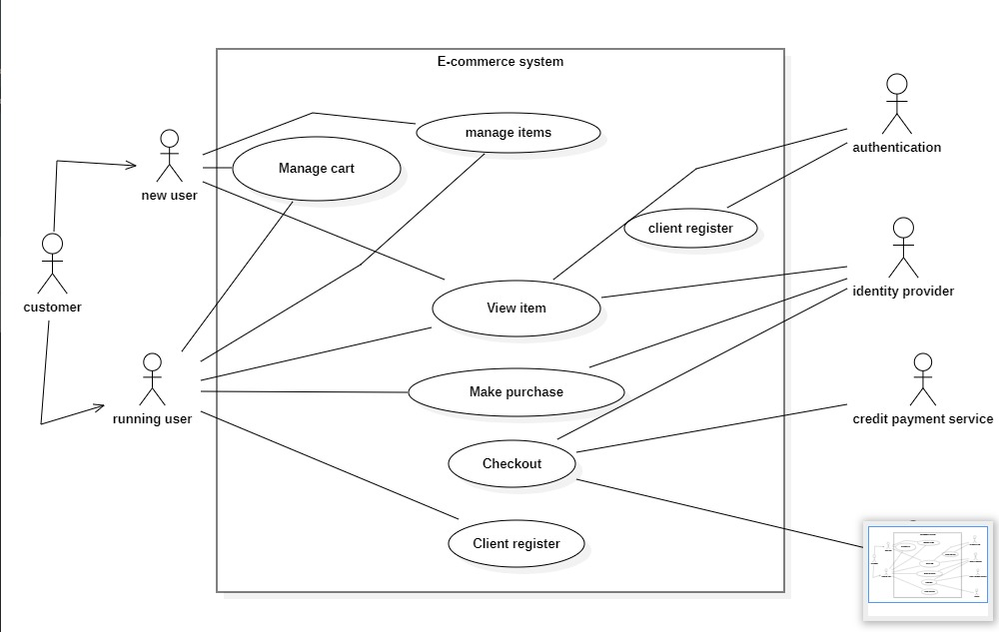

Fig 4.1: Use Case Diagram

**ER-Diagram**

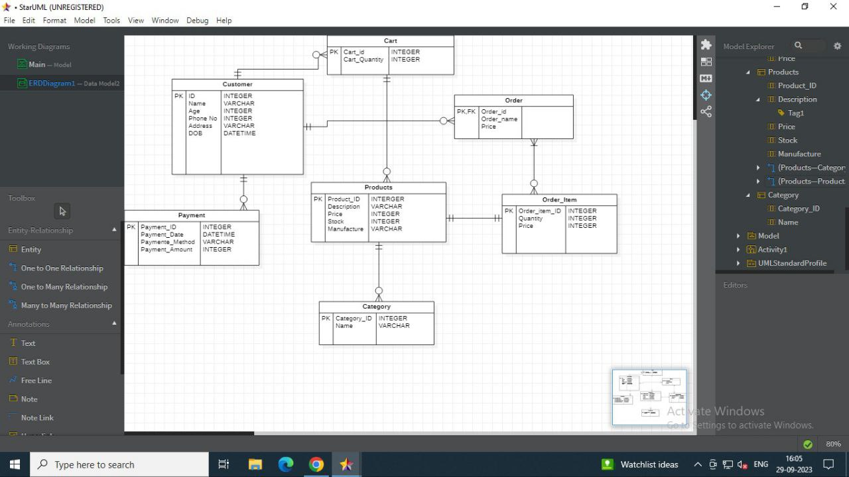

Fig 4.2: ER- Diagram

**Data Flow Diagram**

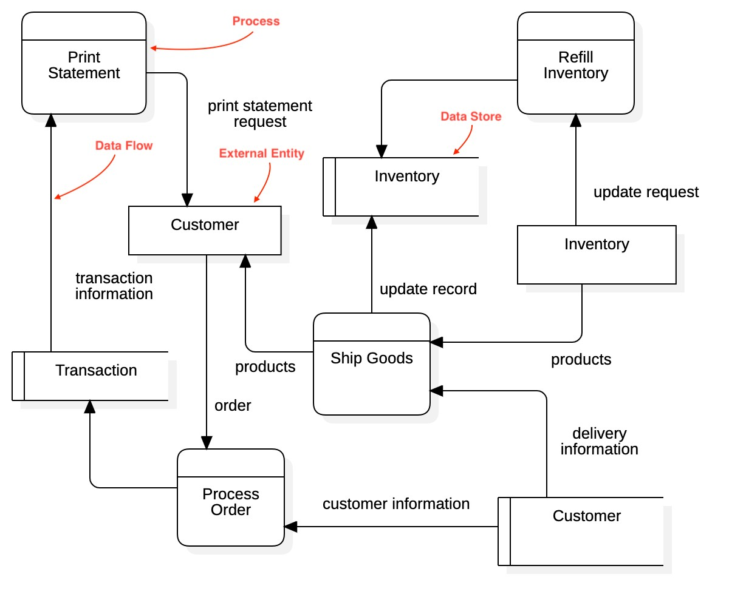Fig4.3: Data Flow Diagram

**Class Diagram**

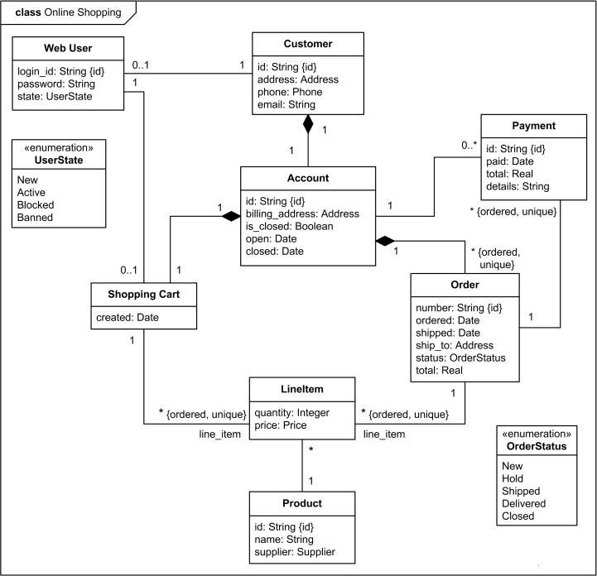

Fig 4.4 Class Diagram

**Level 0 DFD Diagram**

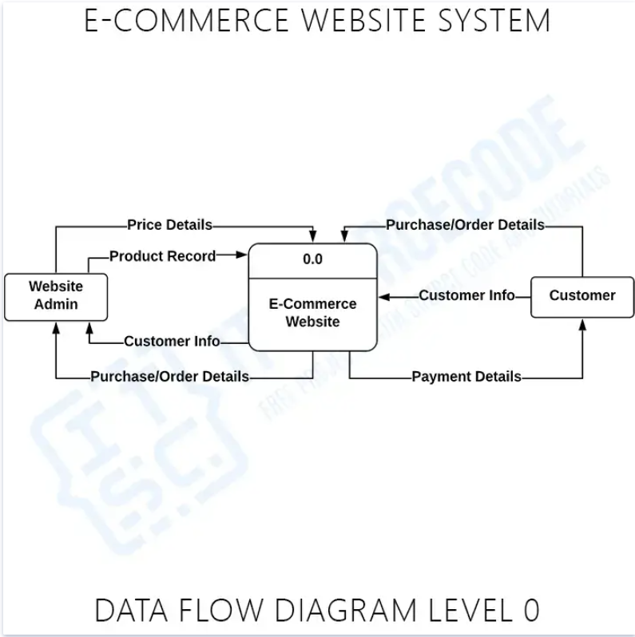

Fig 4.5 Level 0 DFD Diagram

**Level 1 DFD Diagram**

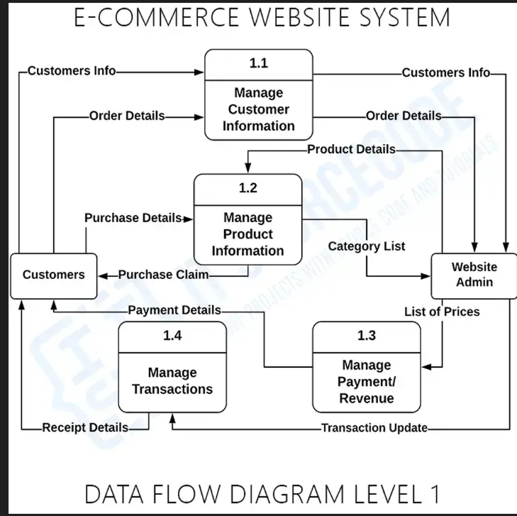

Fig 4.6 Level 1 DFD Diagram

**Level 2 DFD Diagram**

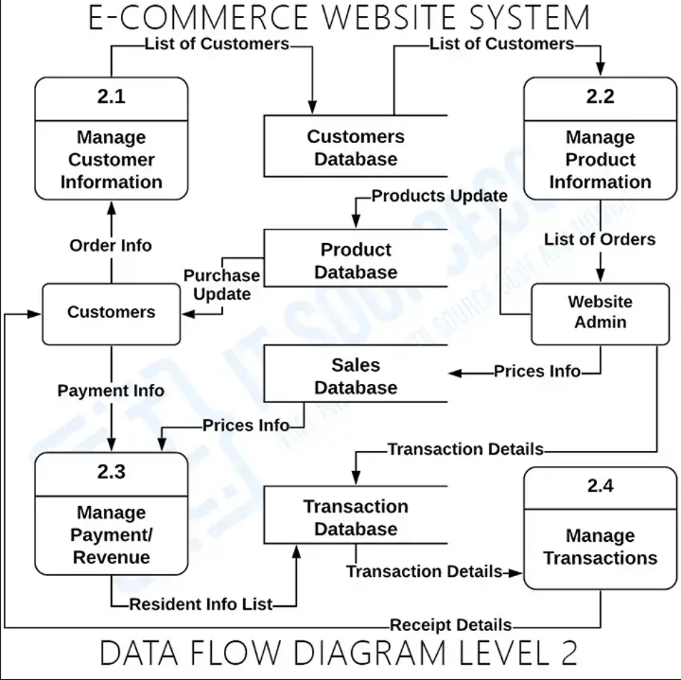

Fig 4.7 Level 2 DFD Diagram

**CHAPTER 5**

**SYSTEM DESIGN**

System design in the software development process is a critical phase where the conceptual requirements gathered during the analysis phase are transformed into a structured and logically working system. This phase focuses on creating a blueprint or roadmap for the software solution that will address the client's needs effectively. Here's a more detailed explanation of the primary and secondary design phases:

**5.1 Primary Design Phase:**

**Block-Level Design:** At this stage, the system is designed at a high level, often referred to as the architectural or block level. The primary goal is to define the overall structure of the system by breaking it down into smaller functional units or blocks. Each block represents a specific module or component of the system.

**Functionality Mapping:** The blocks are created based on the analysis conducted during the problem identification phase. This involves mapping the identified requirements to corresponding functional blocks, ensuring that each block serves a distinct purpose or function within the system.

**Minimizing Information Flow:** Emphasis is placed on minimizing the information flow between blocks to promote modularity, encapsulation, and maintainability. Activities that require close interaction or dependency are grouped together within the same block, while those with minimal interaction are kept separate.

**High-Level Design Documentation:** Documentation is crucial during this phase to capture the high-level design decisions, block diagrams, data flow diagrams, and other architectural artefacts. These documents serve as a reference for developers and stakeholders throughout the software development lifecycle.

**5.2 Secondary Design Phase:**

**Detailed Design:** Once the high-level architecture is established, the focus shifts to the detailed design of each individual block or module identified during the primary design

Phase. This involves defining the internal structure, interfaces, algorithms, data structures, and implementation details for each block.

**Refinement and Optimization:** The detailed design phase allows for further refinement and optimization of the system architecture. Design decisions made during this phase may involve trade-offs between factors such as performance, scalability, flexibility, and maintainability.

**Interface Design:** Special attention is given to designing clear and well-defined interfaces between different modules or subsystems. Interface specifications include input parameters, output formats, error handling mechanisms, and communication protocols to ensure seamless interaction between components.

**Design Review and Validation:** Design artefacts undergo review and validation by stakeholders, including developers, architects, project managers, and clients. Feedback from reviews is incorporated into the design to address any issues or concerns and ensure alignment with project objectives.

Overall, the system design phase plays a crucial role in laying the foundation for the software solution, guiding the development process, and facilitating effective communication between stakeholders. By translating requirements into a structured design, organizations can minimize risks, streamline development efforts, and deliver a robust and scalable software product that meets client expectations.

# **The general tasks involved in the design process are:**

* Design various blocks for overall system processes.
* Design smaller, compact and workable modules in each block.
* Design various database structures.
* Specify details of programs to achieve desired functionality.
* Design the form of inputs, and outputs of the system.
* Perform documentation of the design.
* System reviews.

**5.3 User Interface**

User interface (UI) design encompasses all aspects of the interaction between users and a computer system. It focuses on creating intuitive, visually appealing, and user-friendly interfaces that facilitate efficient and satisfying interactions. Here's a deeper exploration of user interface design:

**Visual Design:** Visual design involves creating the overall look and feel of the interface, including color schemes, typography, icons, and graphical elements. It aims to make the interface aesthetically pleasing while ensuring clarity and readability of content. Visual design plays a crucial role in shaping users' perceptions of the system and enhancing their engagement.

**Layout and Organization:** UI designers are responsible for arranging interface elements in a logical and intuitive manner to guide users through the interaction process. This includes designing the layout of screens, navigation menus, buttons, forms, and other interactive components. A well-organized layout helps users quickly locate information, navigate between different sections, and perform desired actions with ease.

**Information Architecture:** Information architecture involves structuring and organizing the content within the interface to make it easily accessible and understandable. This includes categorizing information, creating hierarchies, and defining navigation pathways to ensure users can find what they need efficiently. Clear labeling and descriptive terminology are essential for effective information architecture.

**Interaction Design:** Interaction design focuses on defining how users interact with the interface and guiding them through various tasks and workflows.

**CHAPTER 6**

**ARCHITECTURE**

# **6.1 Layered Architecture:**

The Layered architecture pattern, also known as the n-tier architecture pattern. This pattern is the de facto standard for most applications and therefore is widely known by most architects, designers, and developers. The layered architecture pattern closely matches the traditional IT communication and organizational structures found in most companies, making it a natural choice for most business application development efforts.

This pattern can be used to structure programs that can be decomposed into groups of subtasks, each of which is at a particular level of abstraction. Each layer provides services to the next higher layer.

The architecture comprises of the following three layers:

**Presentation layer** (also known as **UI layer**)

* The presentation layer is responsible for presenting information to the user and handling user interactions. It includes components such as user interfaces, web pages, forms, and graphical elements that users interact with.
* This layer focuses on delivering a visually appealing and intuitive user experience. It often involves technologies such as HTML, CSS, and JavaScript for web applications, and UI frameworks like React, Angular, or Vue.js.
* The presentation layer communicates with the business logic layer to retrieve and display data, as well as to process user inputs and actions.

**Business logic layer** (also known as **domain layer**)

* The business logic layer contains the core business logic and rules that govern the behavior of the application. It encapsulates the business processes, calculations, validations, and workflows.
* This layer is responsible for implementing business rules and enforcing business policies. It ensures that business operations are performed accurately, consistently, and efficiently.
* The business logic layer often comprises services, entities, and business objects that represent real-world concepts and processes within the domain of the application.
* This layer is technology-agnostic and independent of specific data storage or presentation mechanisms, allowing for easier maintenance, scalability, and reusability of business logic components.

**Data access layer** (also known as **persistence layer**)

* The data access layer is responsible for accessing and manipulating data stored in the underlying data storage systems, such as databases, file systems, or external APIs.
* This layer handles tasks such as querying data, inserting, updating, and deleting records, and managing transactions and connections to the data source.
* The data access layer abstracts the details of data storage and retrieval, providing a consistent interface for the business logic layer to interact with different types of data sources.
* Common technologies used in the data access layer include Object-Relational Mapping (ORM) frameworks, SQL for relational databases, NoSQL query languages for non-relational databases, and HTTP requests for accessing external APIs.

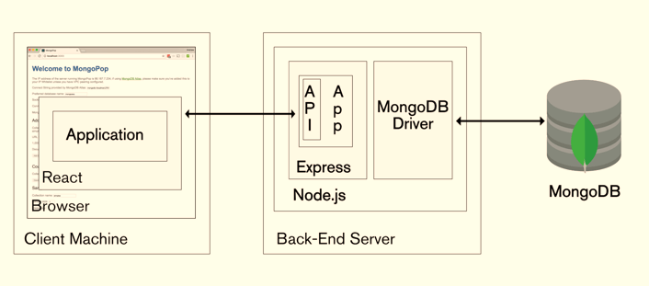

Fig 6.1: Architecture of E-commerce web app

**Chapter 7**

**Project Screenshots**

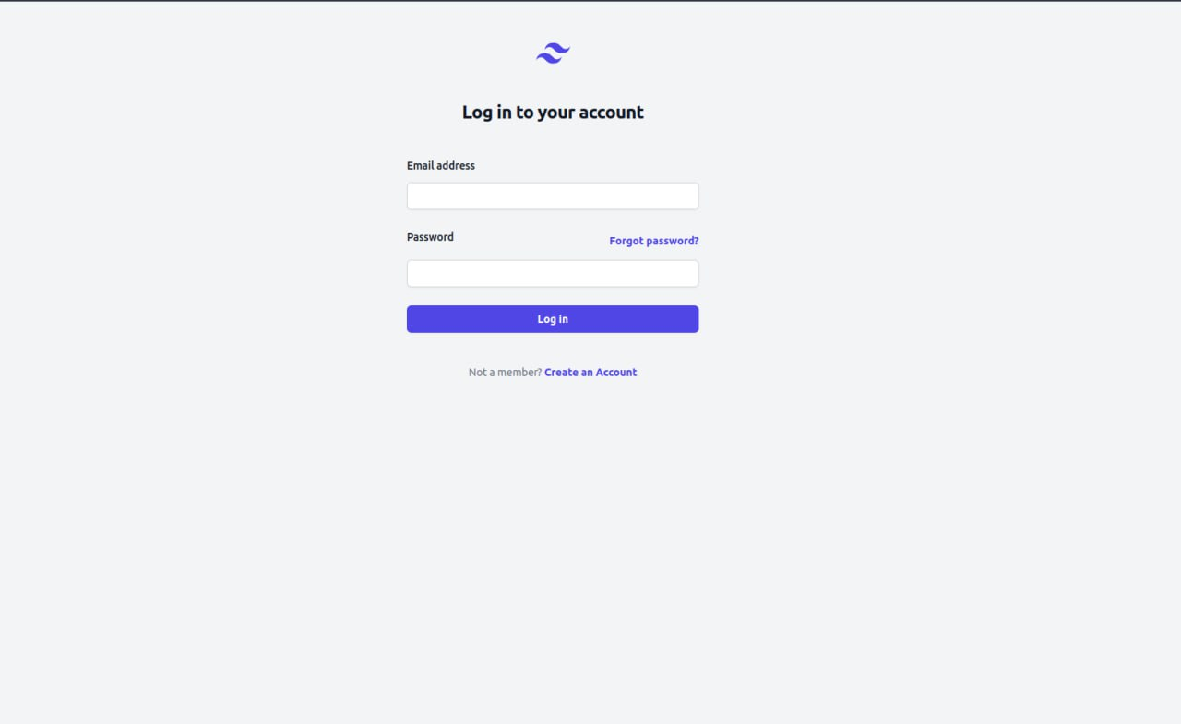

**Fig 7.1 Login Page**

A login page on an e-commerce project serves as the gateway for users to access their accounts securely.

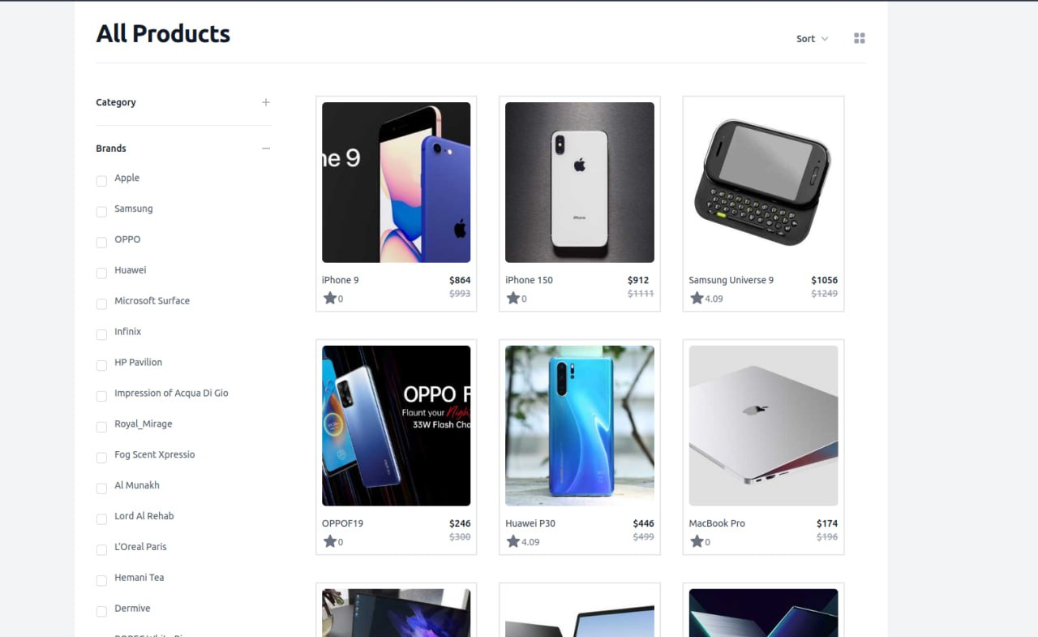

**Fig 7.2 All Products**

The "All Products" display section on an e-commerce project serves as a central hub where users can explore and browse the various products available for purchase.

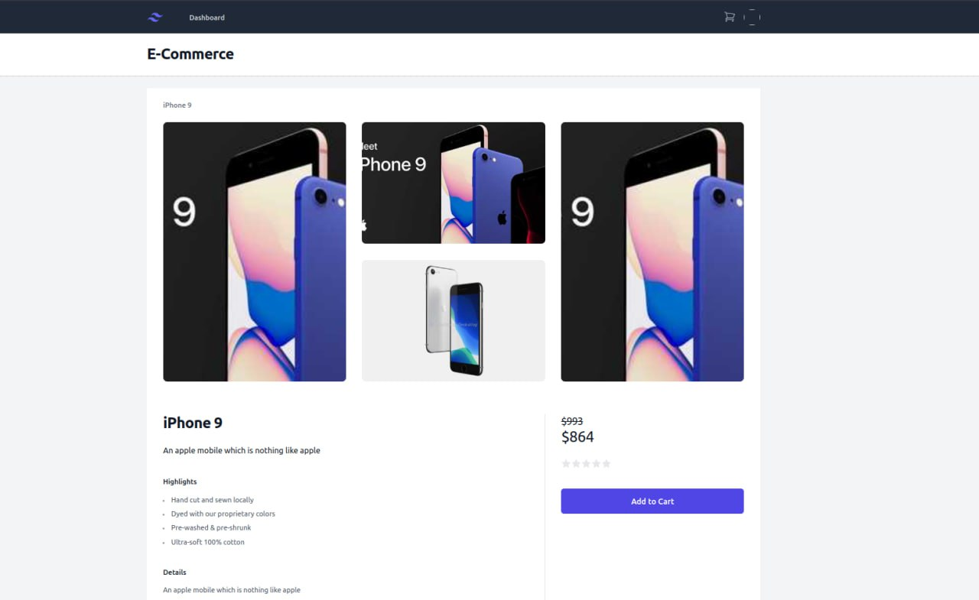

**Fig 7.3 Product Details**

The "Add to Cart" section on an e-commerce project enables users to select products they wish to purchase and add them to their virtual shopping cart.

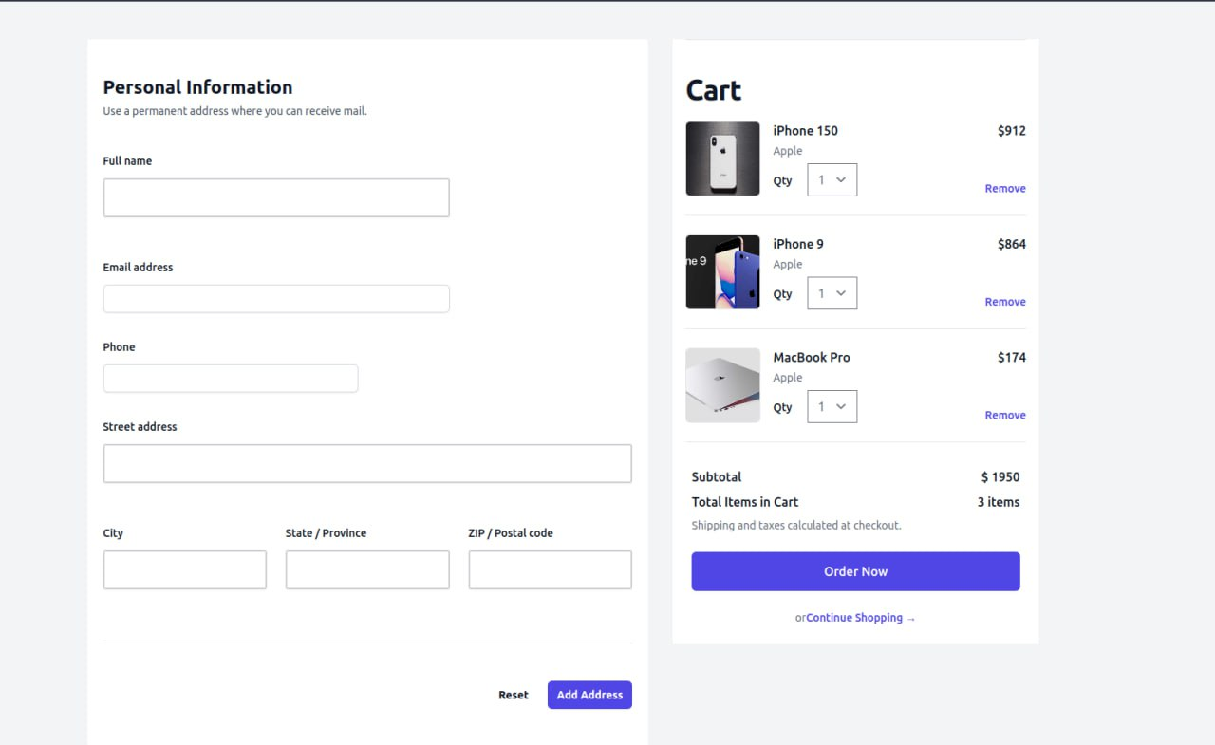

**Fig 7.4 Checkout Page**

The checkout section on an e-commerce project is where users finalize their purchase by providing necessary information and completing the transaction

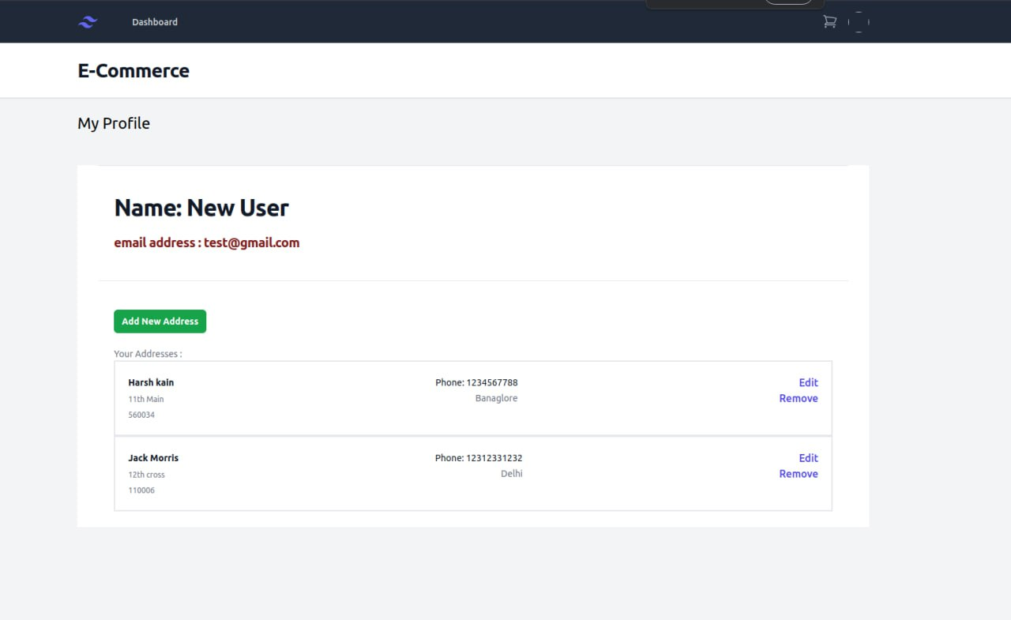

**Fig 7.5 User Profile**

The user profile section on an e-commerce project provides users with a personalized space where they can manage their account information, track orders, and customize their shopping experience.

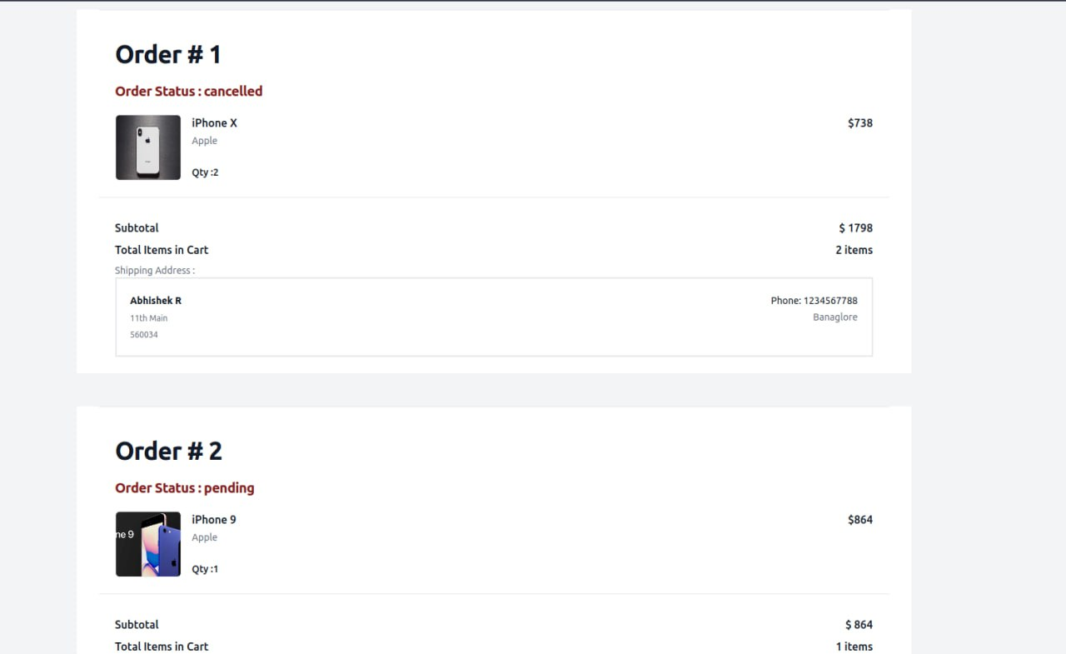

**Fig 7.6 Order History Page**

The order history section on an e-commerce project provides users with a detailed record of their past purchases and order-related information.

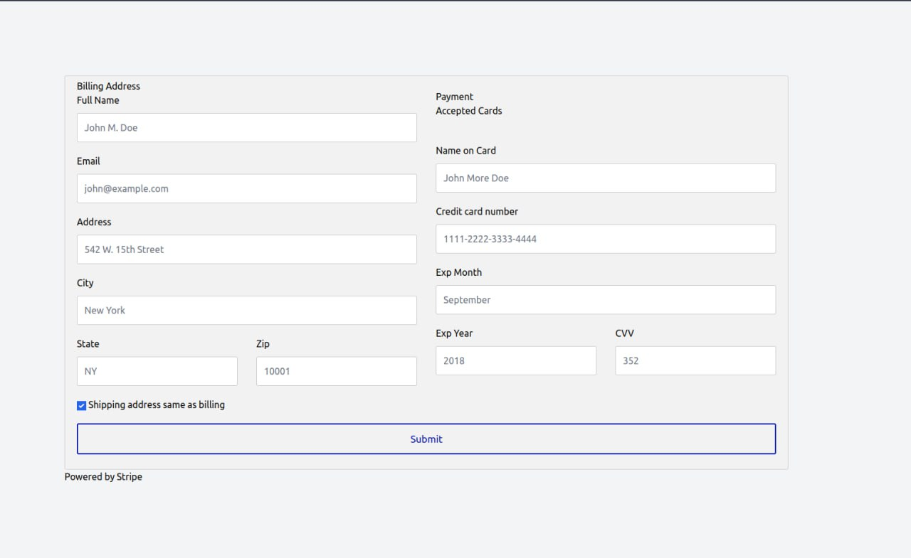

**Fig 7.7 payment page**

The payment page section on an e-commerce project is where users complete the transaction by providing payment information and finalizing their purchase.

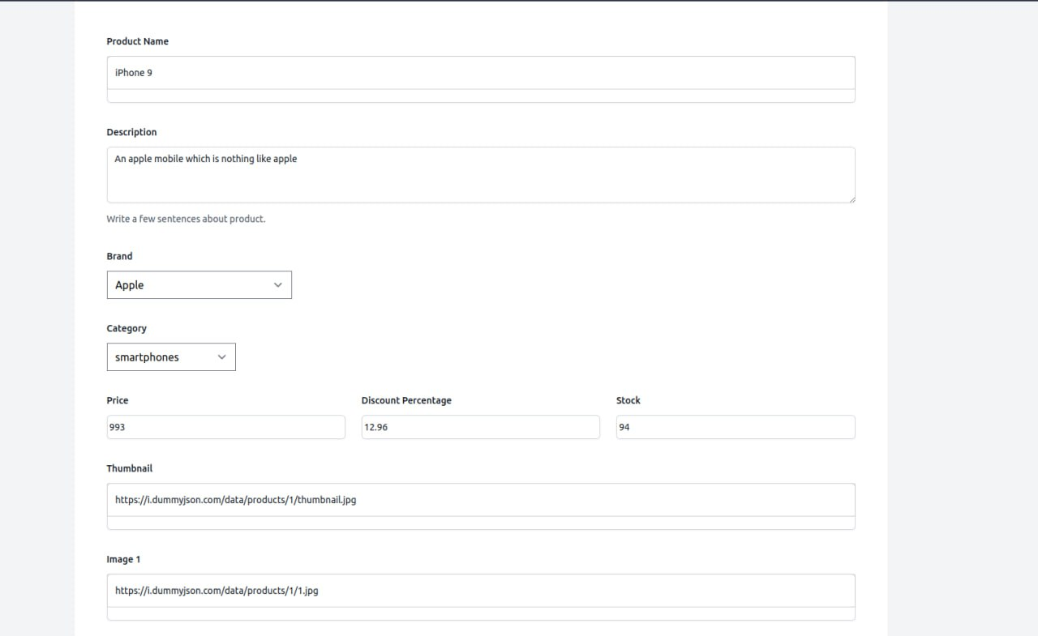

**Fig 7.8 Admin Add Products**

The admin add product section on an e-commerce project is a backend interface that allows administrators or authorized personnel to add new products to the online store.

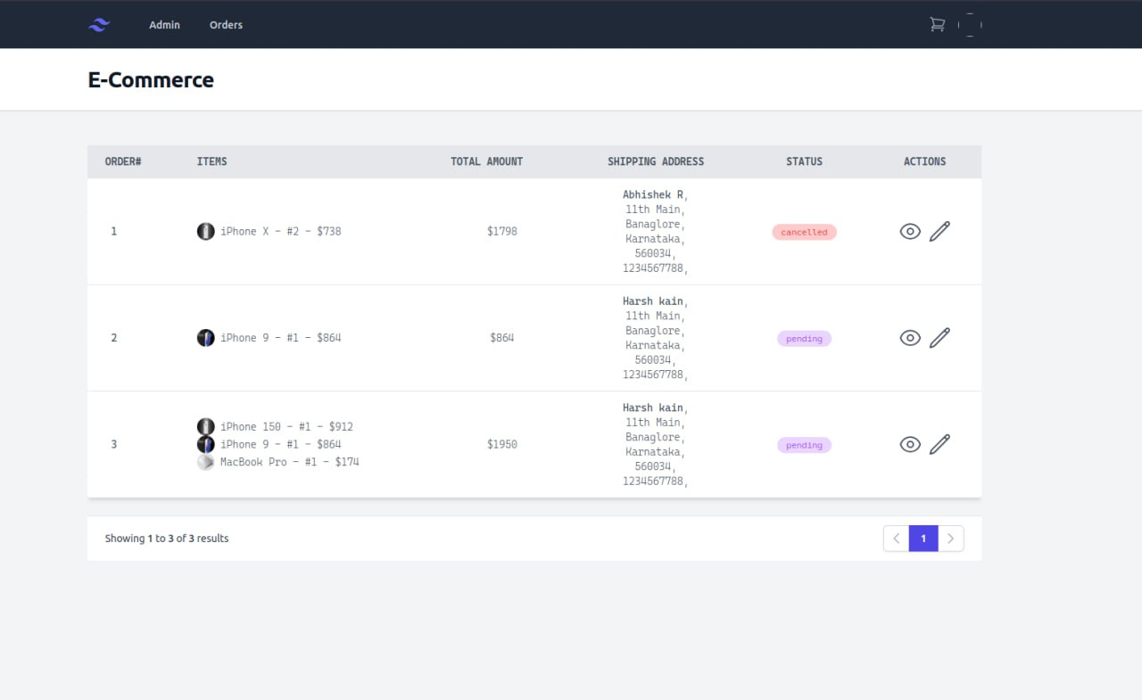

**Fig 7.9 Admin Products Update**

The admin products update section on an e-commerce project provides administrators or authorized personnel with the capability to make changes or updates to existing products within the online store.

**CHAPTER 8**

**Conclusion**

our project, an E-commerce platform developed using the MERN (MongoDB, Express.js, React.js, Node.js) stack, has been meticulously crafted to fulfil the dynamic needs of modern project management within the educational sphere. Throughout the development journey, we have endeavoured to adhere to a user-centric approach, ensuring that the software is not only robust and efficient but also user-friendly.

The project's inception stemmed from a thorough analysis of the existing landscape, recognizing the need for a comprehensive solution to manage project work efficiently within educational institutions. Our endeavour was not merely to reinvent the wheel but to build upon existing frameworks, integrating user-friendly coding practices and contemporary technologies to create a powerful package tailored to the specific needs of schools.

From the outset, we articulated clear aims and objectives, defining the purpose, scope, and applicability of our software. We meticulously delineated the problem domain, laying the groundwork for a detailed exploration of requirement specifications and system functionalities. Through iterative design processes, we developed a robust system model, incorporating features, operations, and security measures while ensuring intuitive user interfaces and seamless user experiences.

The culmination of our efforts lies in the implementation and rigorous testing of the system, meticulously adhering to predefined test cases. This comprehensive approach has not only ensured the reliability and functionality of our E-commerce platform but also instilled confidence in its ability to meet the diverse needs of educational institutions.

In essence, our project stands as a testament to our dedication to excellence and innovation in software planning and development. As we look to the future, we remain committed to refining and enhancing our solution, staying abreast of emerging technologies and evolving user needs to continue delivering impactful solutions in the realm of project management.

**CHAPTER 9**

**Reference**

* <https://www.mongodb.com/>
* <https://legacy.reactjs.org/docs/getting-started.html>
* <https://nodejs.org/docs/latest/api/http://www.jdbc-tutorial.com/>
* <https://expressjs.com/>
* <https://www.npmjs.com/package/json-server>
* <https://www.npmjs.com/package/react-hook-form>
* <https://github.com/>
* <https://www.tutorialspoint.com/java/>
* <https://docs.oracle.com/javase/tutorial/>
* <https://dummyjson.com/>
* <https://rapidapi.com/utelly/api/utelly>
* <https://www.postman.com/>